Q1. Check that each table will display the output presented in the individual tables

**view_customer**

order**

**view_order_item**

**view_outlet**

**view_payment**

**view_staff**

**Q2. Show the output from two of the adjacent tables in turn – that is ordering and customer; staff and ordering.**

**view_order_customer**

**view_staff_order**

**Q3. Connect all three tables and display the output that shows the output from these three tables – customer, ordering and staff.**

**view_customer_order_staff**

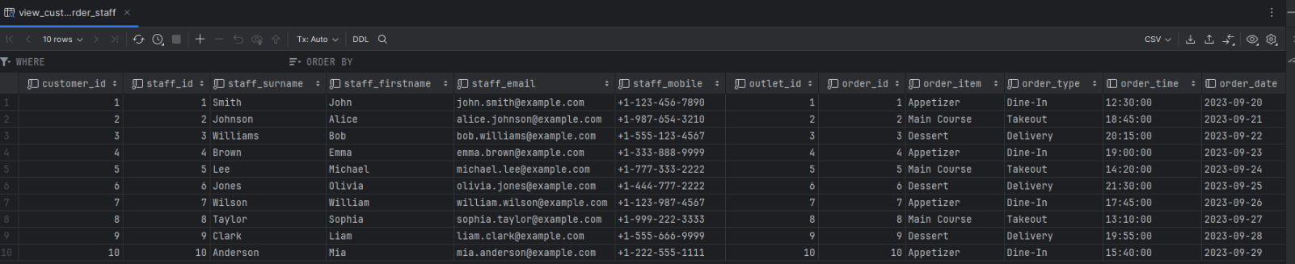

**Q4. Create a query that will show the customer and payment – so link these two tables and produce the output.**

**view_customer_payment**

**Q5. A manager wants to show a catalogue of the items in the system and their quantities.**

**view_order_item_cat**

